# CS 340 README Template

## About the Project/Project Title

This project is developed in conjunction with the rescue-animal training organization Grazioso Salvare, and a partnership with Austin Animal Centers (AAC) in the areas around Austin, Texas. The purpose of the project is to enable Grazioso Salvare to utilize AAC’s database to search for candidate dogs that meet the criteria to become rescue-animals. This project implements query functions to be used on the database in order to narrow the search for suitable dogs.

## Motivation

Grazioso Salvare came to Global Rain in search of a software solution that would allow them to work with existing databases to identify dogs that fit the criteria for their programs. Rescue-animals in certain fields are more effective when they are younger, for example. Their partnership with the local animal shelters are helping find a place for dogs who might otherwise go unadopted. It also provides communities with a valuable service.

## Getting Started

To get started, make sure all files and the assets folder are located in the same project folder. Next using Jupyter Notebook, run the .ipymb file which will generate a localhost url. This can be clicked on to open up the page in a browser where the app can be experimented with. Please refer to the installation resources below if you do not currently have Jupyter Notebook installed on your device.

## Installation

Users who want to use the program may need to install MongoDB and the shell on their computer. This can be found at: <https://www.mongodb.com/docs/manual/installation/>

The Jupyter IDE is used to run the methods on the AAC’s database. Installation for that particular IDE can be found at: <https://jupyter.org/install>

Once both of these things have been installed the user can download the python files and begin to make queries on the database.

## Usage

The program’s middleware makes API calls to the database to filter the data appropriately. These functions make the data dynamically change with the selection, or removal of selection from the dropdown on the webpage. The front-end client side allows a user to view and select animals from a database to observe their locations on a map. A dropdown menu will allow the user to select from a list of preferred breeds of dog to filter the selection based on their strong suits. Water Rescue for example will return a list of dog breeds in the area that are preferential to that occupation. Adjacent to the map is a bar graph illustrating the number of dogs in the area suited to the occupation, broken down by breed.

### Code Examples:

This is the code that filters the different breeds of dog specifically to the occupation. When the dropdown is activated, the list from the breeds object gets passed into the query variable as well as the low and high ages for the dogs. These values create an acceptable age range for dogs who are eligible to become rescue animals.

The following code updates the bar graph to show the number of eligible dogs within each breed by passing the viewData from the dataframe into a variable that is used to create the dogs filter. If no occupation is selected it returns all dogs. If there are no dogs in the database it would return nothing. The code then takes a count for each dog in the list of dogs chose by the dropdown and repopulates the bar graph with the appropriate breed and count. This is reflected in the webpage in real time.

### Tests

Testing the startup shows a dashboard with all animals in the area listed in the database. The bar graph shows all breeds of dog in the area and the map shows the location of the first animal selected, regardless of breed.

Selecting a specific occupation from the dropdown menu will repopulate the dataframe with dogs matching the chosen occupation. The bar chart will also update and the map will show the first dog in the list on the map.

### Screenshots

Dashboard:

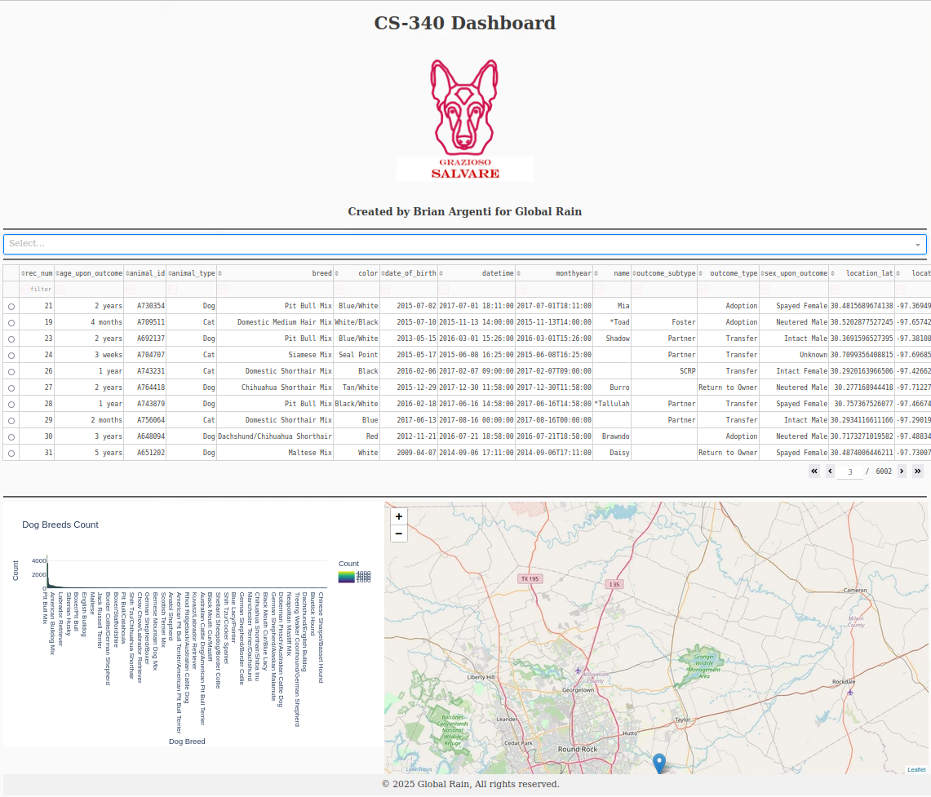

Occupations:

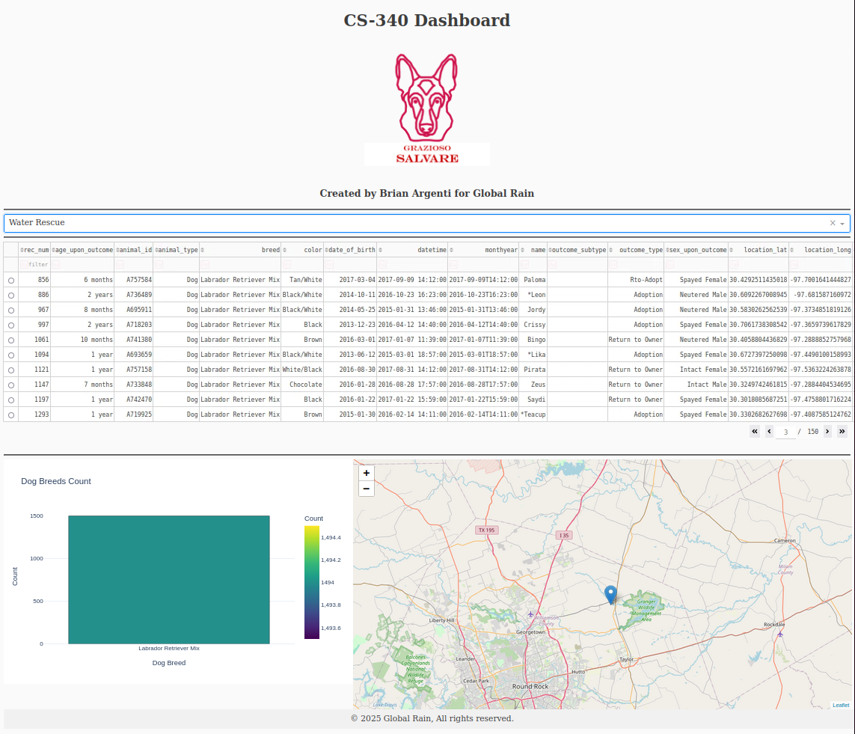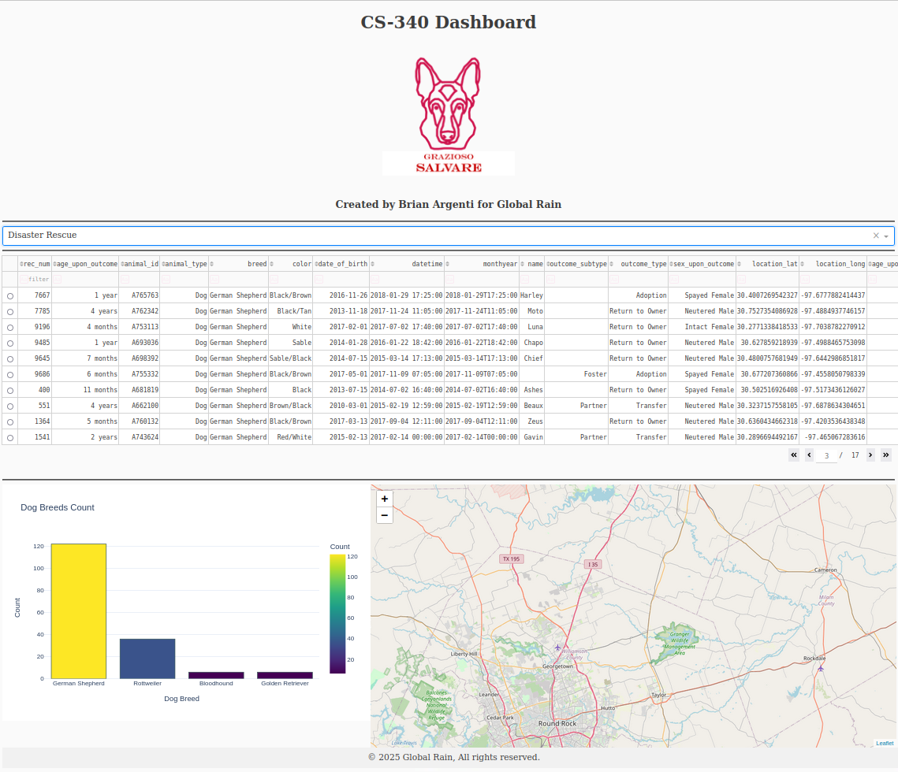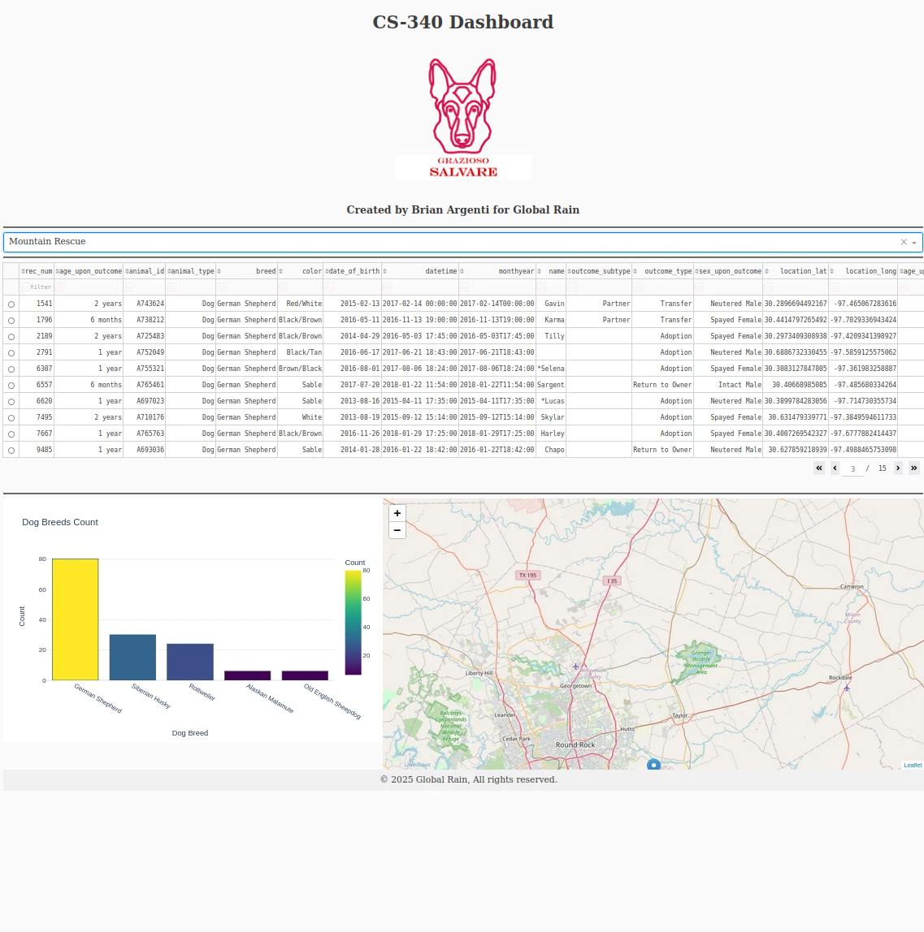

Reset:

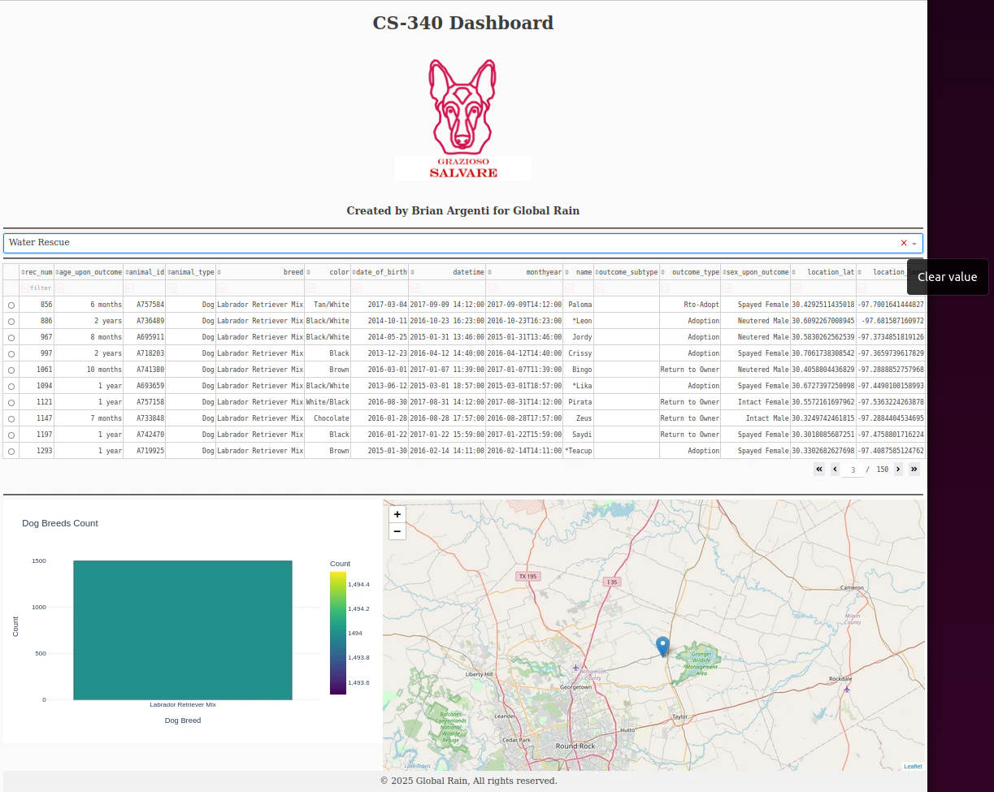

## Roadmap/Features (Optional)

*Provide an open issues list of proposed features (and known issues). If you have ideas for releases in the future, it is a good idea to list them in the README. What makes your project stand out?  
  
Note: This section is optional for the purposes of this assignment. If you choose not to fill out this section, remove it from your final README file.*

## Contact

Your name: Brian Argenti

Email: brian.argenti@snhu.edu